FULL SUBTRACTOR

D = (A $⊕$ B) $⊕CIN$

BR = A’B + A’(CIN) + B(CIN)

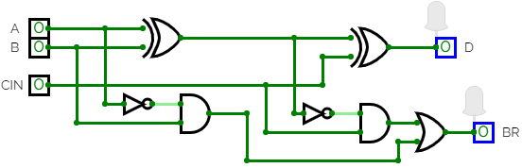

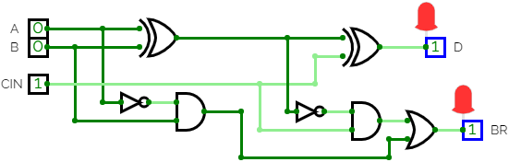

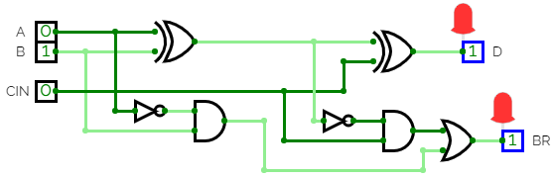

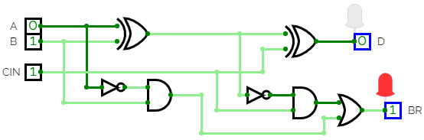

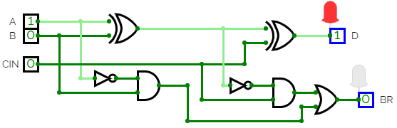

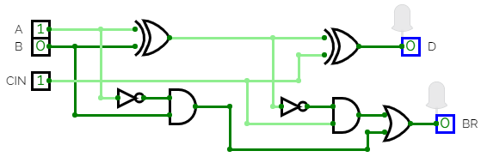





HENCE FULL SUBTRACTOR IS IMPLEMENTED.